`

**Walaa Jamous and Selim Bayrak**

INM704 Agents and Multi-Agents Systems (COURSE 2020-21)



Assignment

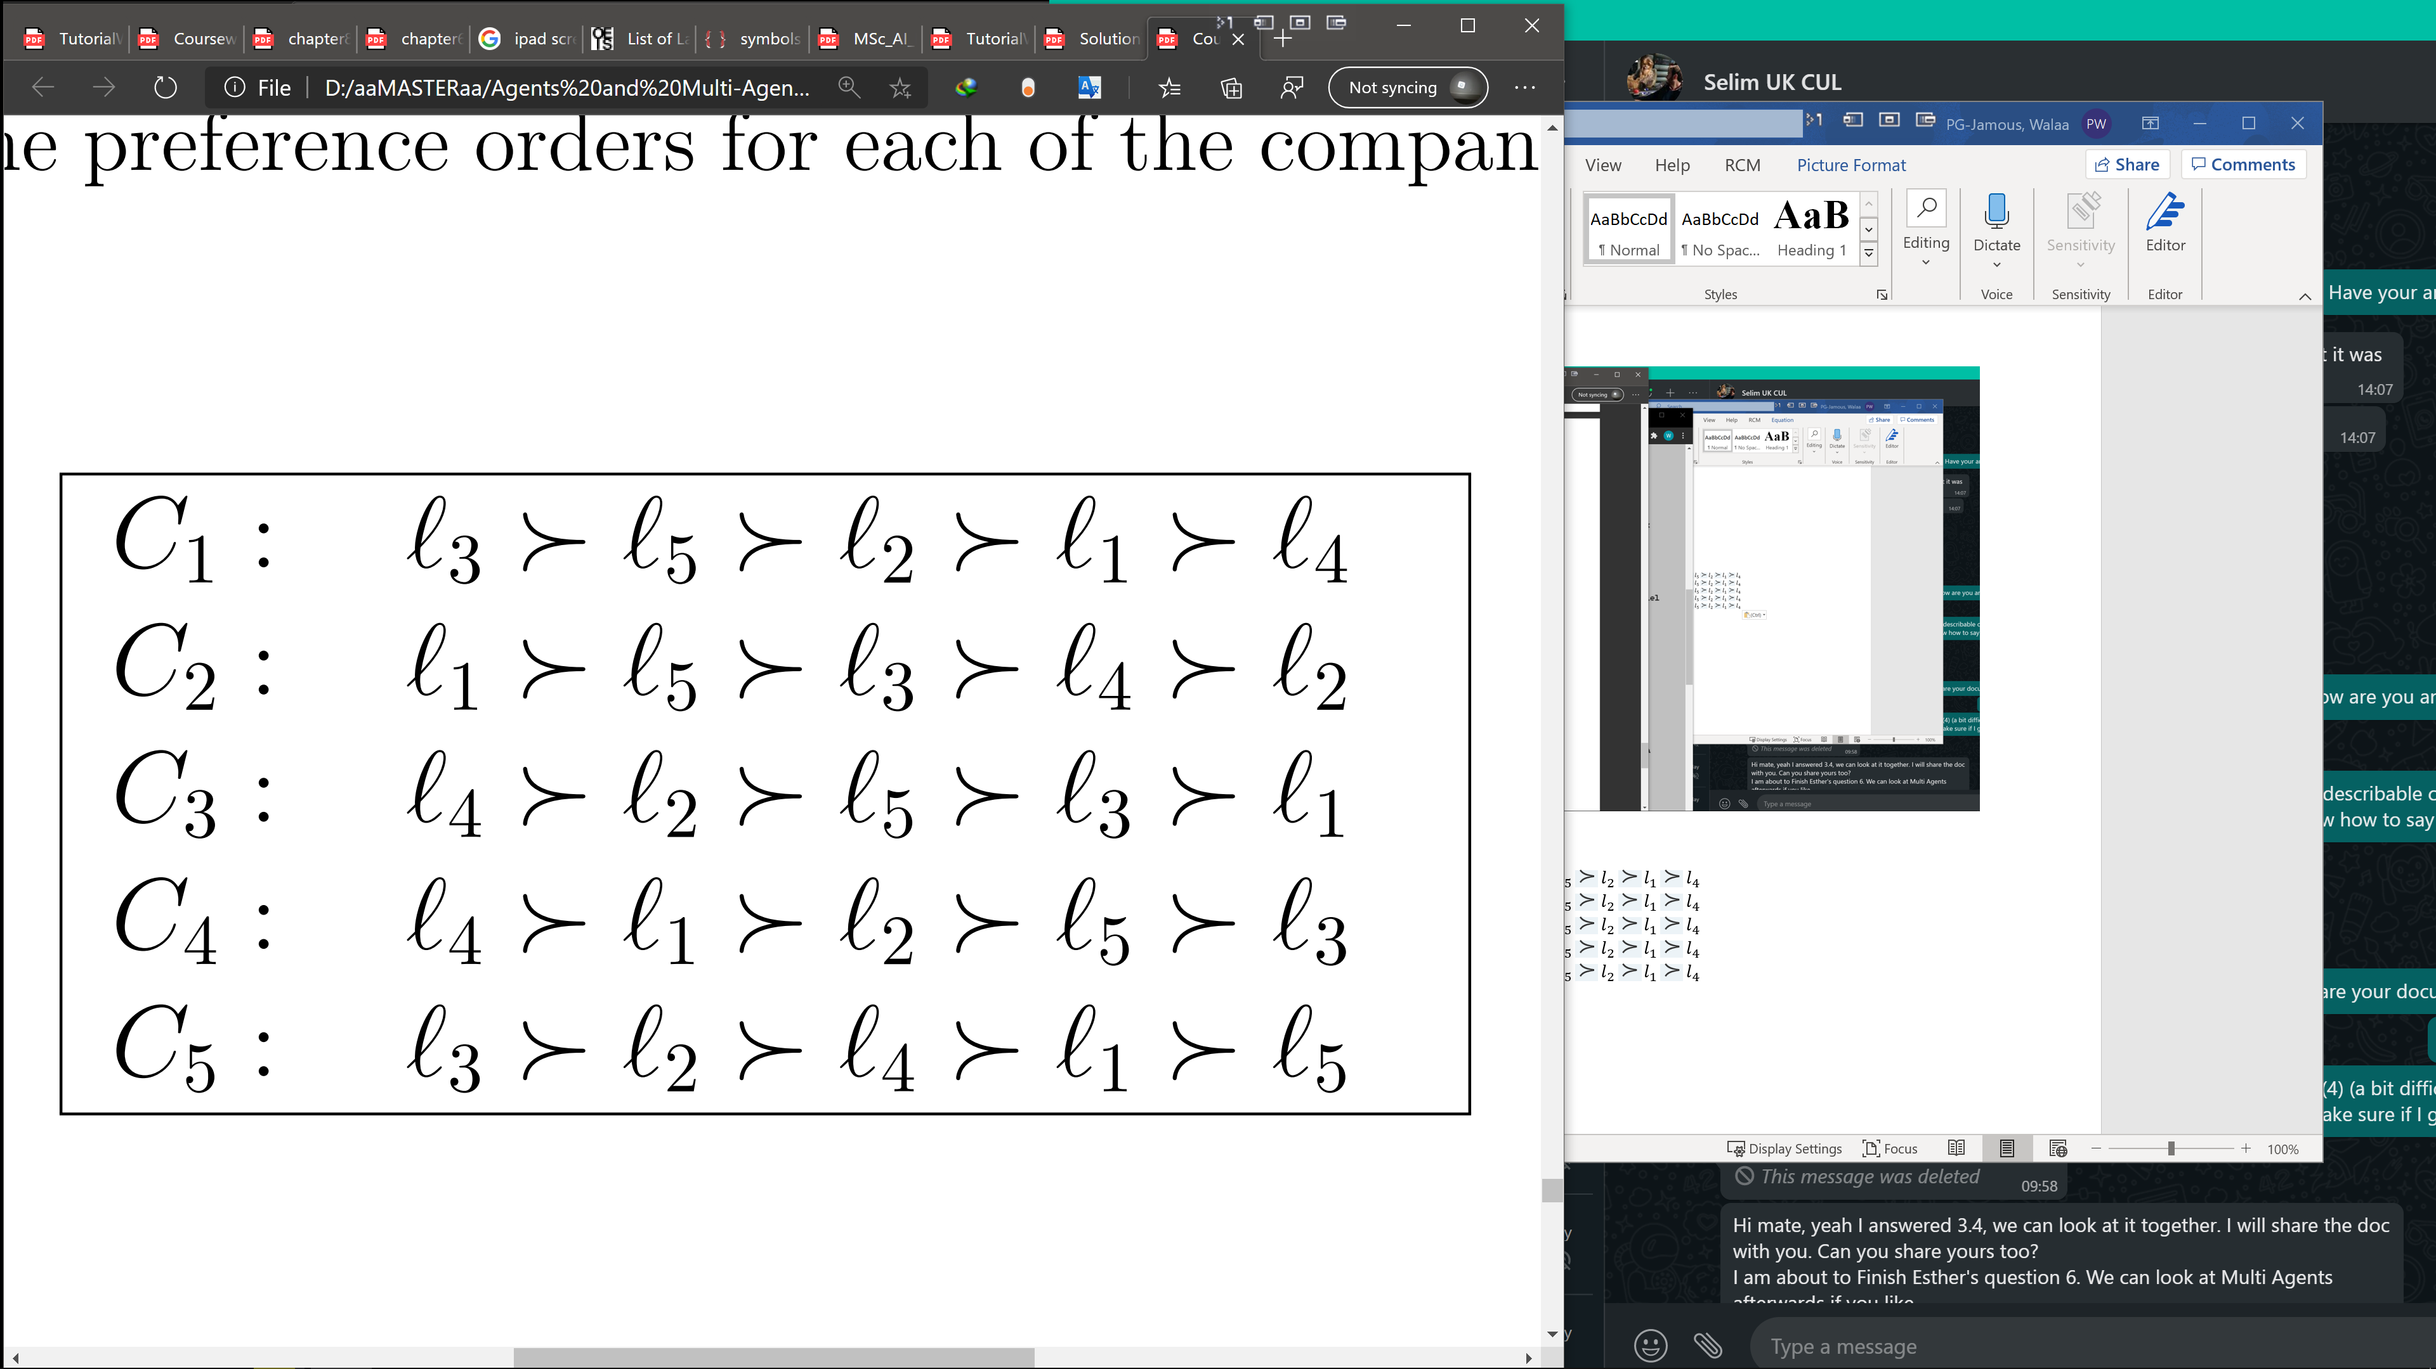

The following table describe the formulas above. If the vertices in the column is preferred compared to the vertices in the row we describe it by “yes”. And “No” if it is not preferred.

|  |  |  |  |  |  |  |  |  |  |  |  |  |  |  |  |  |
| --- | --- | --- | --- | --- | --- | --- | --- | --- | --- | --- | --- | --- | --- | --- | --- | --- |
| C1 | l1 | l2 | l3 | l4 |  | C2 | l1 | l2 | l3 | l4 |  | C3 | l1 | l2 | l3 | l4 |
| l1 | ↓ |  |  |  |  | l1 | ↓ |  |  |  |  | l1 | ↓ |  |  |  |
| l2 | No | ↓ |  |  |  | l2 | Yes | ↓ |  |  |  | l2 | No | ↓ |  |  |
| l3 | No | No | ↓ |  |  | l3 | Yes | No | ↓ |  |  | l3 | No | Yes | ↓ |  |
| l4 | Yes | Yes | Yes | ↓ |  | l4 | Yes | No | Yes | ↓ |  | l4 | No | No | No | ↓ |
| l5 | No | No | Yes | No |  | l5 | Yes | No | No | No |  | l5 | No | Yes | No | Yes |
|  |  |  |  |  |  |  |  |  |  |  |  |  |  |  |  |  |
| C4 | l1 | l2 | l3 | l4 |  | C5 | l1 | l2 | l3 | l4 |  |  |  |  |  |  |
| l1 | ↓ |  |  |  |  | l1 | ↓ |  |  |  |  |  |  |  |  |  |
| l2 | Yes | ↓ |  |  |  | l2 | No | ↓ |  |  |  |  |  |  |  |  |
| l3 | Yes | Yes | ↓ |  |  | l3 | No | No | ↓ |  |  |  |  |  |  |  |
| l4 | No | No | No | ↓ |  | l4 | No | Yes | Yes | ↓ |  |  |  |  |  |  |
| l5 | Yes | Yes | No | Yes |  | l5 | Yes | Yes | Yes | Yes |  |  |  |  |  |  |

By calculating the majority vote on each edge we determine the direction of the most voted edge. The tables below shows the result

|  |  |  |  |  |
| --- | --- | --- | --- | --- |
| Total | l1 | l2 | l3 | l4 |
| l1 | ↓ |  | Voting Majority | |
| l2 | No | ↓ |
| l3 | No | No | ↓ |  |
| l4 | No | No | Yes | ↓ |
| l5 | Yes | Yes | No | Yes |

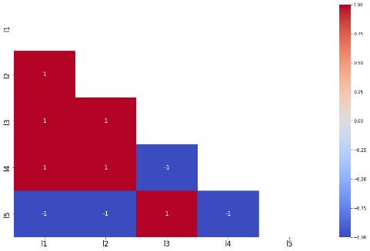

Table: Python code that calculate loops and the majority vote developed for this coursework

Let us draw the graph of the majority vote:

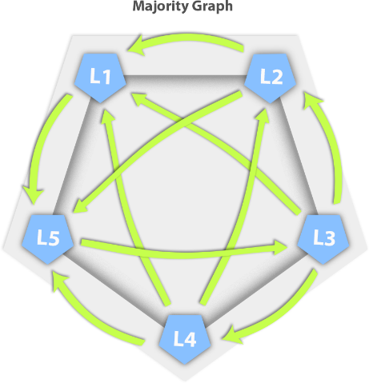

The illustration bellows shows the loops.

If we flip some edges like L2 - L1 and L5 – L3 edge we get preference formula with rank two, However, from the graph at the bottom right, the orange edge is a common edge between all six loops, and we actually get Staler Rank preference by flipping L5 – L3, with rank one and this the only way to get rank one. The graph below bellow shows the two graphs after flipping:

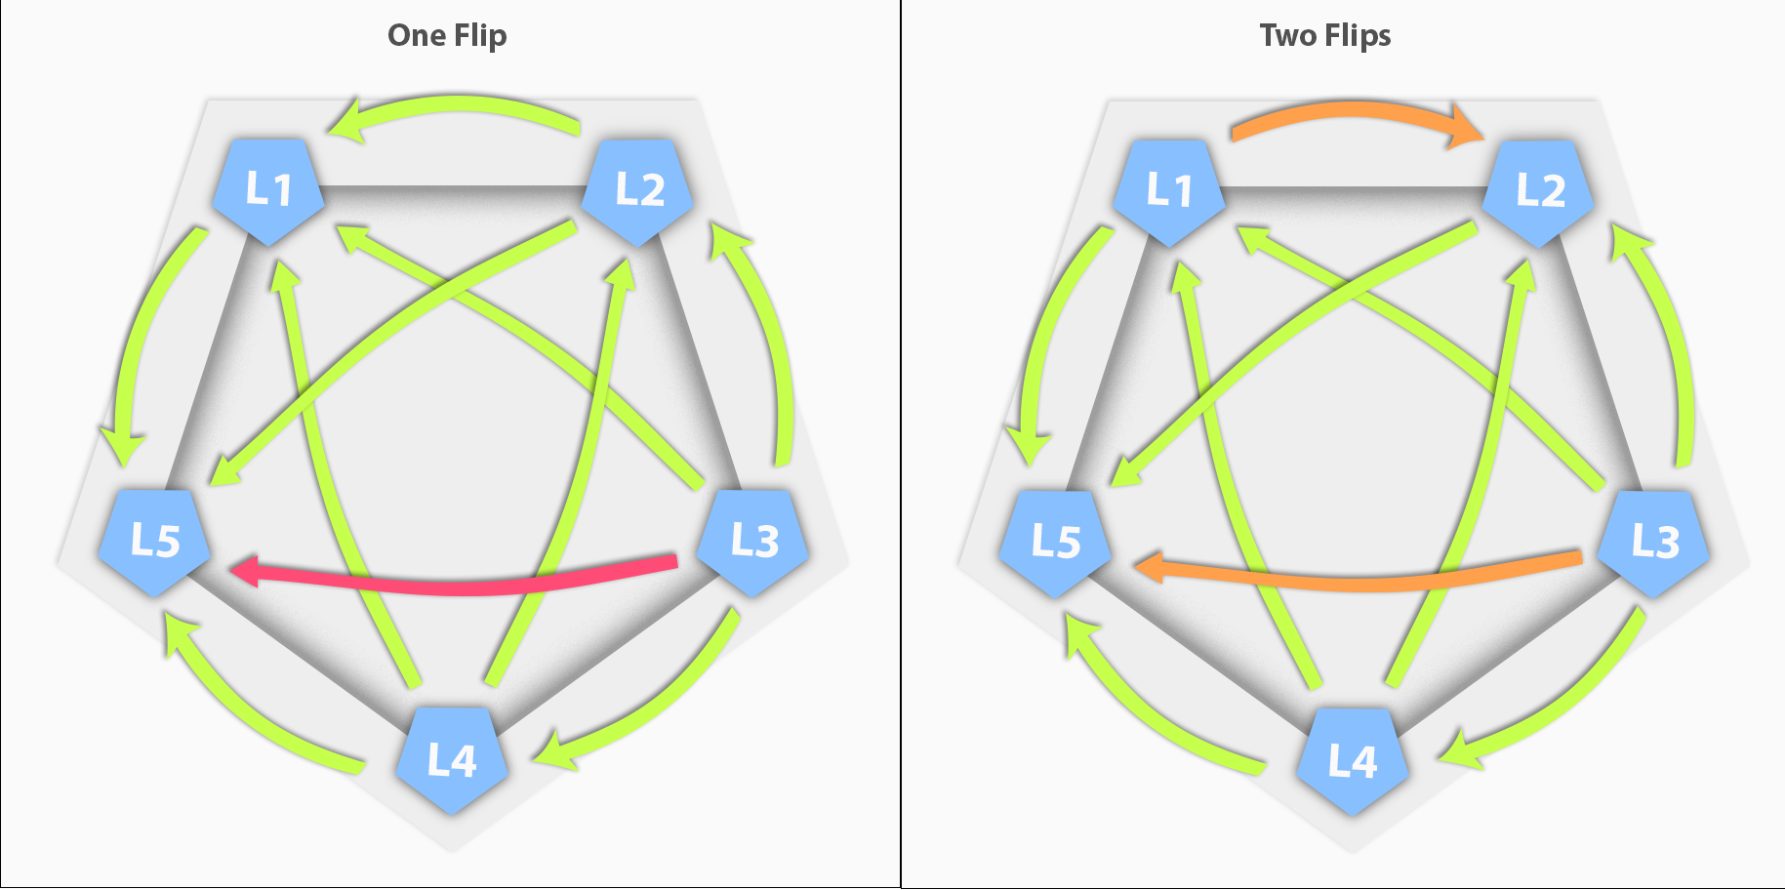

First Ranked Slater:

F1 **=** l3 **≻** l4 **≻** l2 **≻** l1 **≻** l5

Second Ranked Slater:

F 2 **=** l4 **≻** l3 **≻** l1 **≻** l2 **≻** l5

Our goal is to minimize the rank. Therefore, the first formula is the chosen formula.

**2. Explain the advantages and drawbacks of this type of voting system. Justify fully your answer**

**Pros:**

It is a great way and in many scenarios fair to find the majority preferrable choice. Plus when this is not the case it gives fair approach that satisfy the majority.

**Cons:**

1- Computing: Computing the slater rank non-polynomial hard “NP”. Which means once the number of edges/vertices increases the computing increases dramatically “almost Exponentially”.

2- If we have a graph with two w (two preference orders -with the same rank- that could both win) or more, as in the example in the next question. We need to choose one of them, this is for sure allows a space of manipulation. That means whom ever choose can have an agenda that favor some candidates.

3- The whole process is not fully fair for example in the previous, despite that many company actually likes L5. But, it ranked last.

4- The formula can be manipulated, if one of the company knows the other companies selections. It can for example prefer it second candidate the most because it knows, the most preferred candidate has no way to win.

**3. Give an example with five locations and five companies, all having different preference orders such that a voting system based on the Slater rank would give at least two winners ex-aequo (two preference orders that could both win).**

Let us take the following formula:

C 1 **=** l4 **≻** l1 **≻** l2 **≻** l3 **≻** l5

C 2 **=** l4 **≻** l2 **≻** l1 **≻** l3 **≻** l5

C 3 **=** l4 **≻** l3 **≻** l1 **≻** l2 **≻** l5

C 4 **=** l4 **≻** l2 **≻** l3 **≻** l1 **≻** l5

C 5 **=** l4 **≻** l3 **≻** l1 **≻** l2 **≻** l5

The majority graph will be as in next graph. Also the red edges shows the only loop exist in the graph.

Here are two, ranked one, winner options.

O 1 **=** l4 **≻** l3 **≻** l2 **≻** l1 **≻** l5

O 2 **=** l4 **≻** l2 **≻** l3 **≻** l1 **≻** l5

